|  |  |  |  |
| --- | --- | --- | --- |
| Scale | Distances | Distances |  |
| Large | North and South sides of the salar | ~20km | Microbiomes subject to majorly different climates |
| Medium | Top and bottom of a hill | ~300m | Microbiomes subject to slightly different local climates |
| Small | Inter-halite differences in the same site | ~10m | Microbiomes in segregated and structurally unique nodules |
| Tiny | Intra-halite differences in the same nodule | ~10cm | Micro-niches in the same halite, subject to different conditions depending on position |

*Table 1: Overview of the study design looking into halite microbial community differences across different scales of community diversity.*

**MAIN FIGURES:**

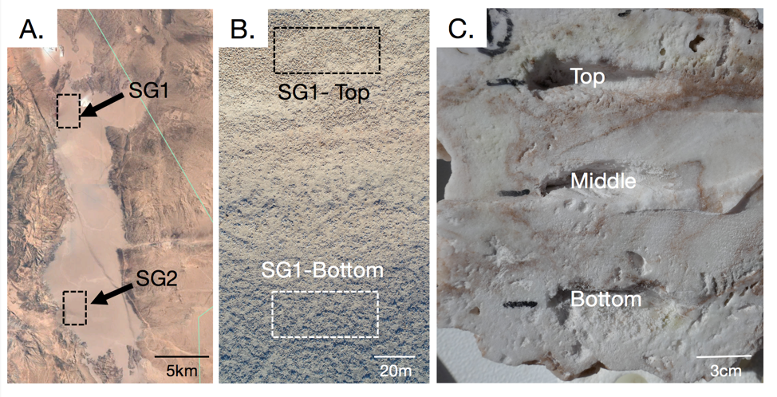

*Fig. 1: (A) Google Earth view of the entire Salar Grande flat, highlighting the sampling regions named SG1 and SG2. (B) A top-down drone image of the slope of the hill at SG1, showing the sampling areas at the top and bottom of the hill. (C) A cross-section of a model halite nodule, showing the locations of samples taken from the top, middle and bottom of the nodule in respect to its original orientation in the field.*



*Fig. 2: Temperature (A) and relative humidity (B) fluctuations at SG1-Top over an average day. Data was simultaneously collected 1m above the ground (“Air”) and with HOBO probes sealed inside a halite near the top, middle, and bottom of the nodule. Highlight lines represent the moving average of the data over 100 data points. Weather data was collected every 5 minutes from 2018-03-01 to 2018-5-1.*



*Fig. 3: Effective light transmission inside halite nodules, measured 10mm from the top surface and in the center of the nodule. The center positions were taken to be the middle of the three halites, 30mm, 20mm, and 38mm from the surface, respectively. The transmission spectra of each halite were normalized to the mean transmission from the top position to bring out the top-middle differences over the inter-nodule differences.*



*Fig. 4: PCoA of Weighted Unifrac dissimilarity matrix of 16S rDNA amplicon sequences, comparing community compositions in samples from different locations in the “large” and “medium” sampling scales. A: samples from SG1 and SG2 (difference is significant, PERMANOVA: pval<0.001, test statistic= 28.36). B: samples from SG1-top and SG1-bottom (difference is significant, PERMANOVA: pval=* 0.001*, test statistic= 22.5).*



*Fig. 5: PCoA of the Weighted Unifrac dissimilarity matrix of 16S rDNA amplicon sequences, comparing community compositions in samples collected from different positions within the halite nodules. The scatterplot projections show the third and fourth principal components, coloring the samples by A) the sample’s relative vertical position within the halites, and B) the sample’s distance to the nodule’s surface.*

**

*Fig. 6: Average relative abundances of the major halite microbiome phyla in samples collected in A) SG1 vs SG2 and B) SG1-top vs SG1-bottom. The relative abundance of Chlorophyta was inferred from the relative abundance of the chloroplast 16S rRNA gene. Bars above each phyla represent Student’s t-test significance, and the asterix count denotes the associated p-value (***: pval<0.0001, **: pval<0.001, *: pval<0.01).*



*Fig. 7: Relative abundance of major halite microbiome phyla inside the halite nodules at different distances from the nodule surface. The relative abundances were standardized to the average abundance of that phyla the sampled nodule slice. The line corresponds to a linear line of best fit. Chlorophyta (chloroplast) sequences were only detected at low abundances is a few samples, and are not shown here.* top and bottom of the nodules have equally close to the surface, and cannot be distinguished

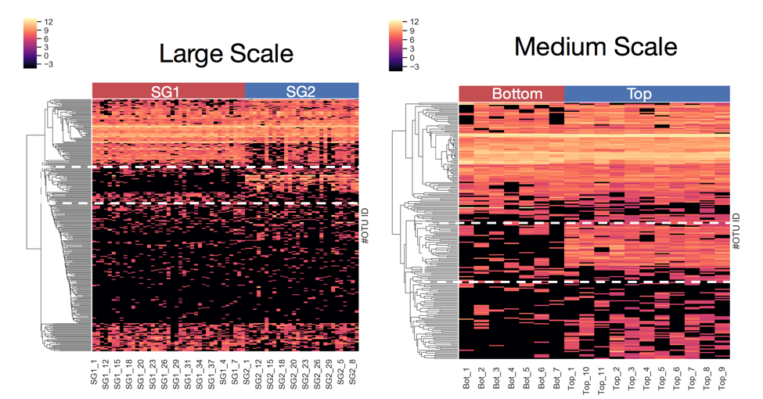

Fig. 8: Heat map comparting different in relative abundance of OTUs (y-axis) in samples (x-axis) from A) SG1 and SG2, and B) top and bottom of SG1.



*Fig. 9: Bray-Curtis dissimilarity between microbial communities in halite samples from different sites, compared across different distance scales: large (SG1 vs SG2), medium (SG1-top vs SG1-bottom), inter-halite (samples from different halites at SG1-top), intra-halite (samples from the same halites at SG1-top), and same position (samples from the same same halites and the same vertical position). Boxplots contain the dissimilarity between all possible inter-sample comparisons in the considered samples groups.*

**SUPPLEMENTARY FIGURES:**



*Fig. S1: Climate data comparisons for large (SG1 vs SG2; A-C) and medium (top vs bottom of SG1, D-F) scales. Weather measurements were collected simultaneously at the two compared sites, showing differences in temperature (A, D) and relative humidity (B, E) of the locations. Colors denote the time (hours after midnight) of data collection for each point. The number of hours in the day when halites experienced deliquescence was estimated from the time when the relative humidity was above 75% (C, F). Paired weather data was collected hourly from 2018-03-01 to 2018-05-01 with a HOBO probe located 1m above the ground.*

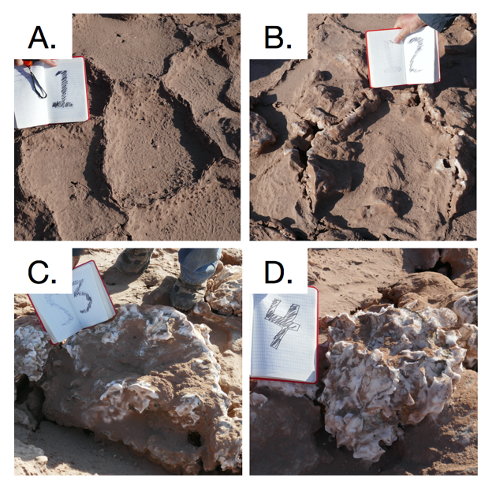

*Fig S2: Example photos of the stages of halite nodule development: a flat polygon (A), a rising polygon (B), a halite nodule (C), a fully mature halite nodule (D). 20cm notebook shown for scale.*



*Fig. S3: Distribution of halite nodules across the surface of different locations in Salar Grande. The relative distribution percentage was estimated from 6 randomized 100m transects, along salt formations were classified according stages of nodule formation, from a flat polygon to a mature halite nodule.*



Fig S4: Cell count density within the top, middle, and bottom samples in the different halite slices. Cell counts were estimated by counting nuclei per field of view with an automated cell-counting pipeline. Halite are denoted H1-H6, and slices within each halite are denoted A-C. Each point represents a technical replicate from a single field of view.



Fig. S5: The average cell density of each biological sample, standardized to the maximum value within each slice (y-axis).

**

*Fig. S6: PCoA of the Weighted Unifrac dissimilarity matrix of 16S rDNA amplicon sequences, comparing community compositions in samples collected from different positions within the halite nodules. The scatterplot projections show the first and second principal components, coloring the samples by A) the samples’ relative vertical position within the halites, B) the halite nodule, and C) the vertical slice of the samples’ (each slice is labeled randomly with a color-shape combination).*

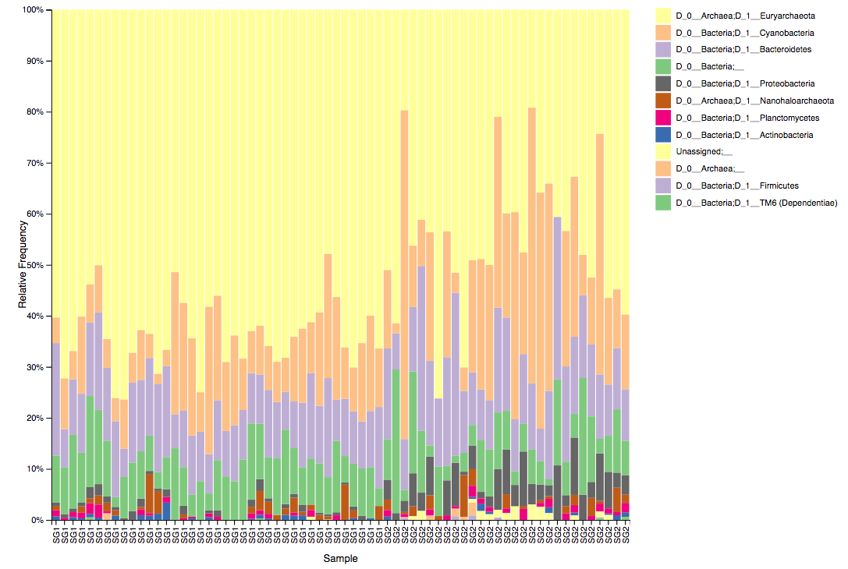

*Fig. S7: Relative taxonomy composition of SG1 and SG2 locations at the D3 (phylum level). Note that chloroplast sequences are included under the “Cyanobacteria” phylum in Qiime2.*



*Fig. S8: Relative taxonomy composition of halite communities at the top and bottom of the SG1 hill in 2016 at the phylum level. Note that chloroplast sequences are included under the “Cyanobacteria” phylum in Qiime2.*



*Fig. S9: Relative abundance of major halite microbiome phyla inside the halite nodules at the top, middle and bottom positions within each sampled nodule slice. The relative abundances were standardized to the average abundance of that phyla in each slice. Chlorophyta (chloroplast) sequences were only detected at low abundances is a few samples, and are not shown here. Bars above each phyla represent Student’s t-test significance, and the stars denote the associated p-value (***: pval<0.0001, **: pval<0.001, *: pval<0.01).*

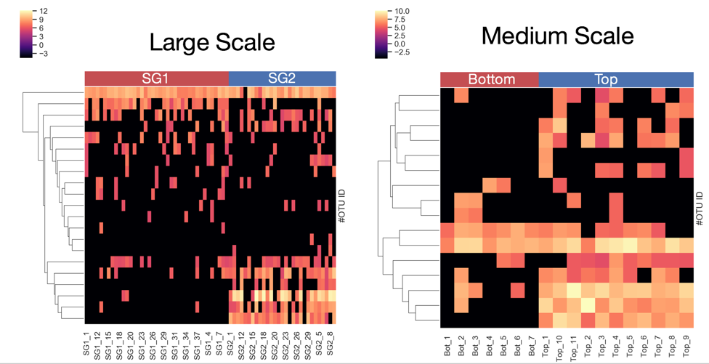

Fig. S10: Heat map comparting different in relative abundance of *Proteobacteria* OTUs (y-axis) in samples (x-axis) from A) SG1 and SG2, and B) top and bottom of SG1.